**EXERCISE 6 – INHERITANCE & OVERLOADING**

**CLASS DIAGRAM – EX 6.1, EX 6.2, EX 6.3**

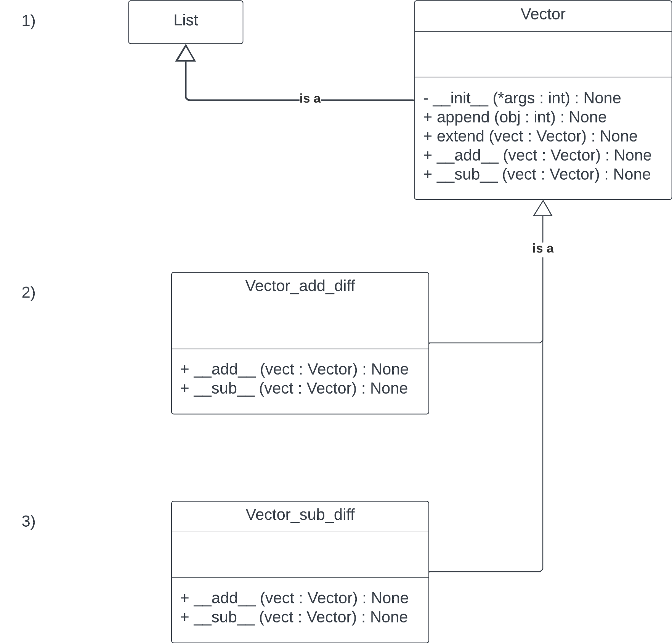

**CLASS DIAGRAM – EX 6.4**

**PACKAGE DIAGRAM**

